K8S_Task03 namespace & MetalLB
- Create blue and red namespaces
# kubectl create namespace blue
# kubectl create namespace red
# kubectl get ns
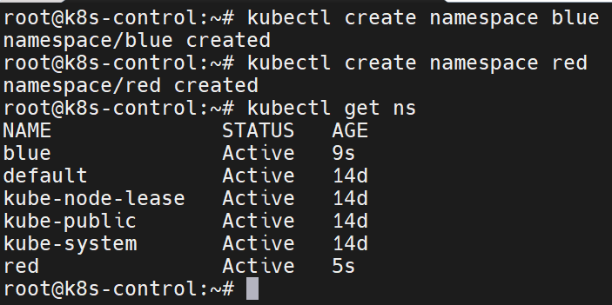
- Create deployment & service on blue namespace for Nexus
# vim nexus-deployment.yaml
# kubectl apply -f nexus-deployment.yaml
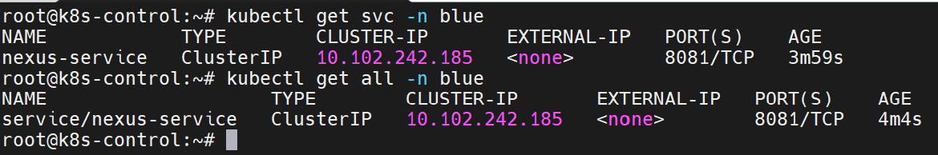

apiVersion: apps/v1
kind: Deployment
metadata:
name: nexus
namespace: blue
labels:
app: nexus
spec:
replicas: 1
selector:
matchLabels:
app: nexus
template:
metadata:
labels:
app: nexus
spec:
containers:
- name: nexus
image: sonatype/nexus3
ports:
- containerPort: 8081
---
apiVersion: v1
kind: Service
metadata:
name: nexus
namespace: blue
spec:
type: ClusterIP
selector:
app: nexus
ports:
- protocol: TCP
port: 8081
targetPort: 8081
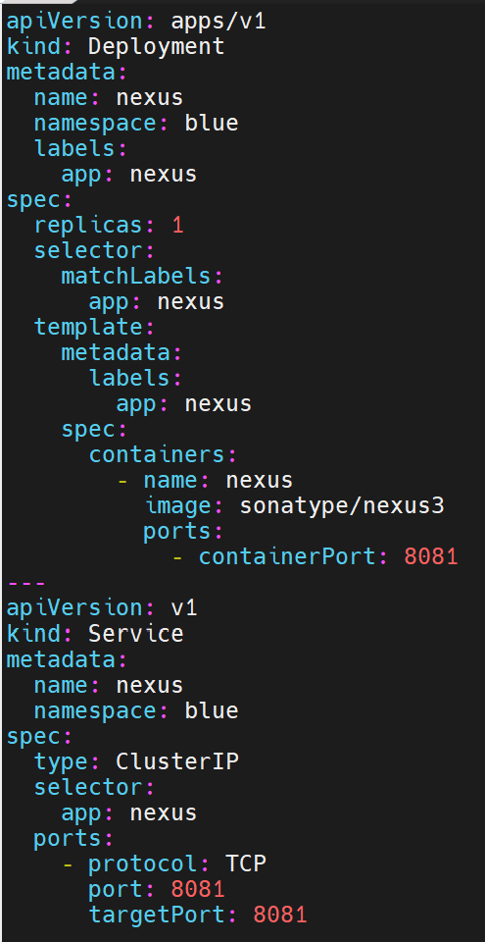.

- Create nginx-proxy-config
# vim nginx-proxy-config.yaml
# kubectl apply -f nginx-proxy-config.yaml
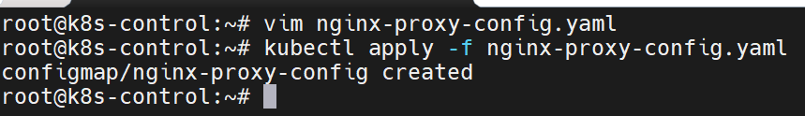

apiVersion: v1
kind: ConfigMap
metadata:
name: nginx-proxy-config
namespace: red
data:
default.conf: |
server {
listen 80;

location / {
proxy_pass http://nexus.blue.svc.cluster.local:8081;

proxy_set_header Host nexus.blue.svc.cluster.local;
proxy_set_header X-Real-IP $remote_addr;
proxy_set_header X-Forwarded-For $proxy_add_x_forwarded_for;
proxy_set_header X-Forwarded-Proto $scheme;
}
}

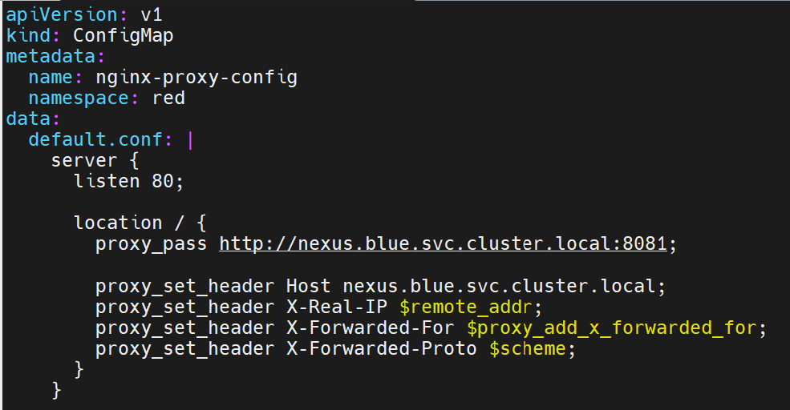
- Create deployment & service on red namespace for Nginx
# vim nginx-deployment.yaml
# kubectl apply -f nginx-deployment.yaml
# kubectl get all -n red
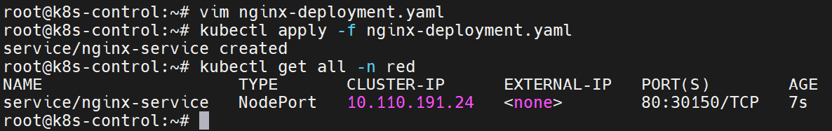

apiVersion: apps/v1
kind: Deployment
metadata:
name: nginx
namespace: red
labels:
app: nginx
spec:
replicas: 1
selector:
matchLabels:
app: nginx
template:
metadata:
labels:
app: nginx
spec:
containers:
- name: nginx
image: nginx
ports:
- containerPort: 80
volumeMounts:
- name: nginx-config-volume
mountPath: /etc/nginx/conf.d/default.conf
subPath: default.conf
volumes:
- name: nginx-config-volume
configMap:
name: nginx-proxy-config
---
apiVersion: v1
kind: Service
metadata:
name: nginx-service
namespace: red
spec:
type: NodePort
selector:
app: nginx
ports:
- protocol: TCP
port: 80
targetPort: 80
nodePort: 30150

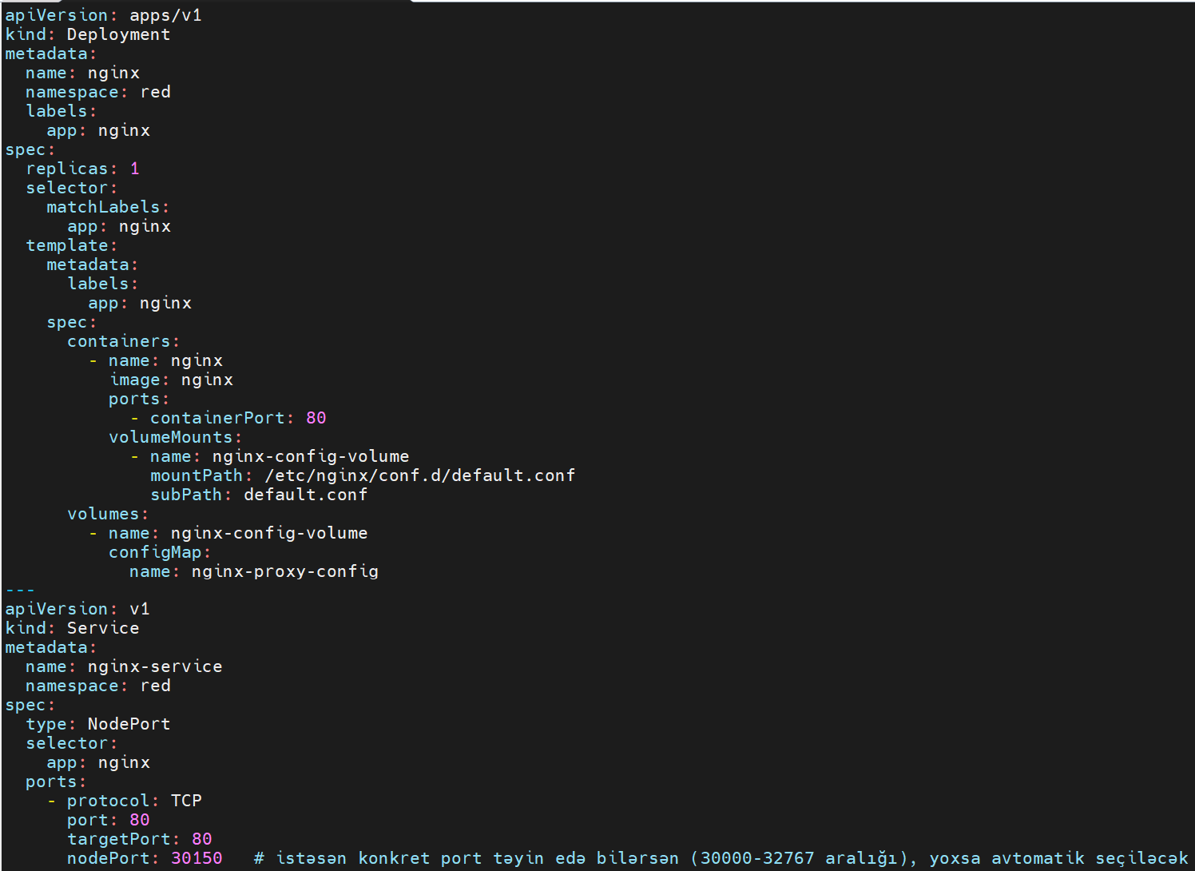

- Check
# kubectl get pods -n blue -o wide
# kubectl get pods -n red -o wide
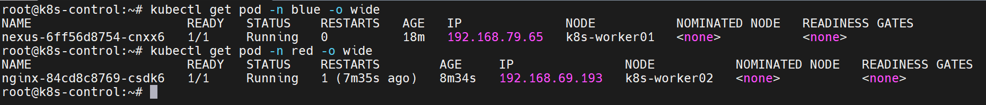

- Go to web http://192.168.153.11:30150/
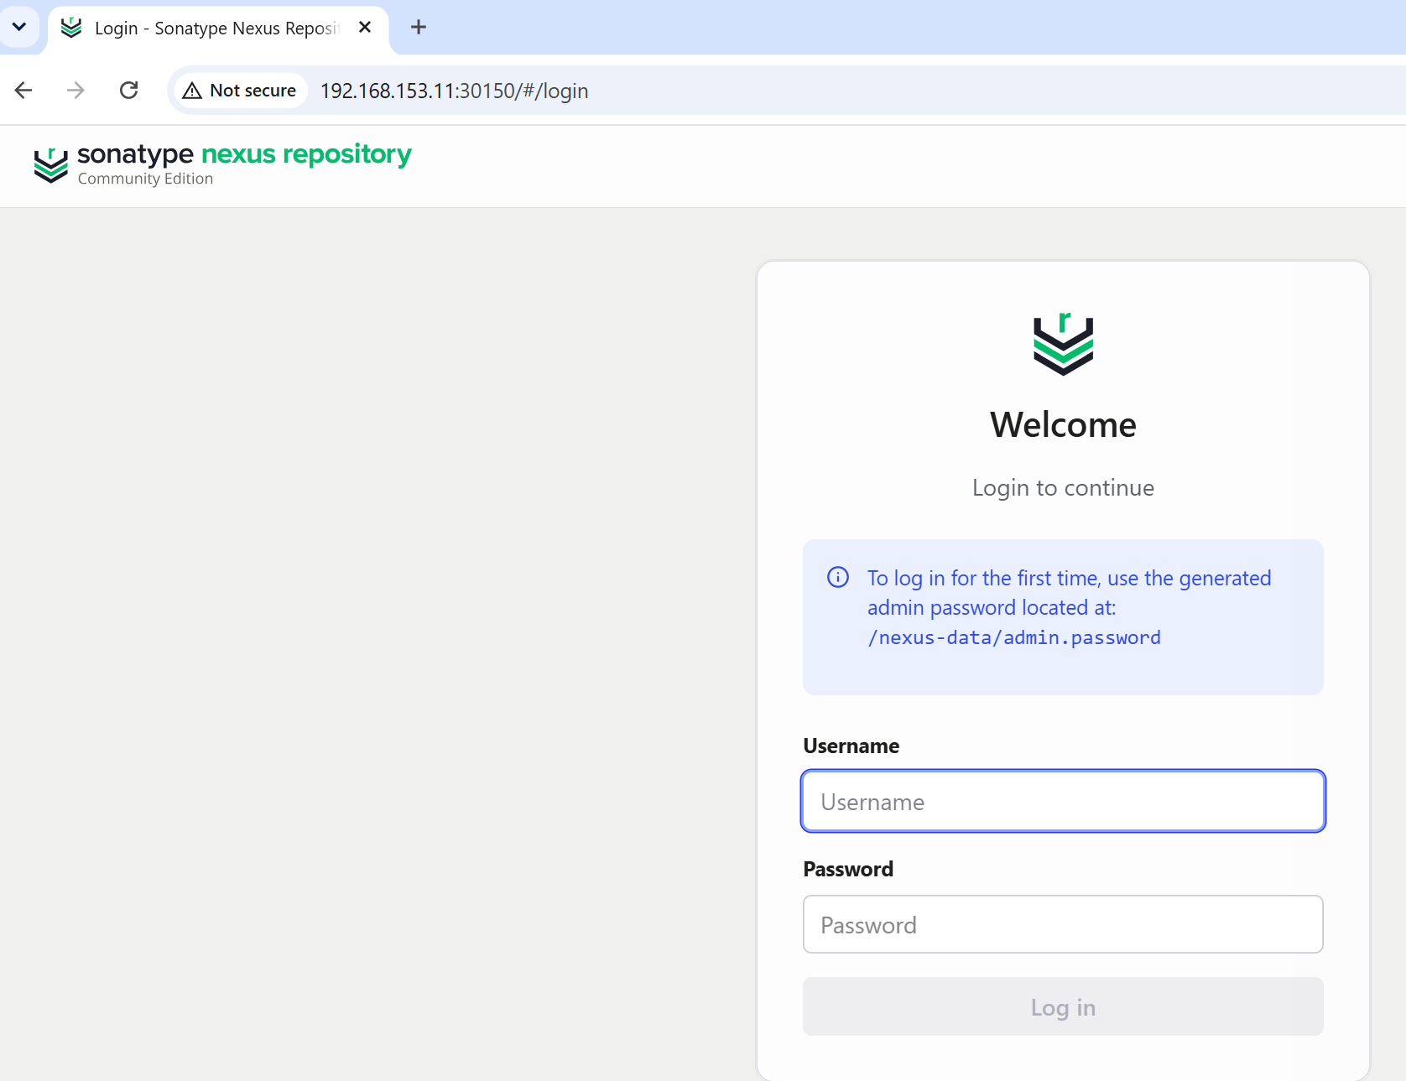
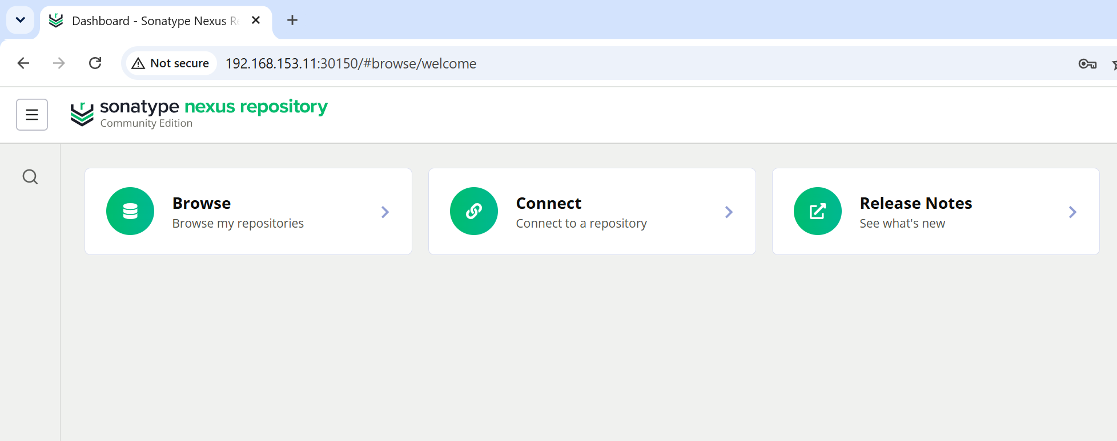
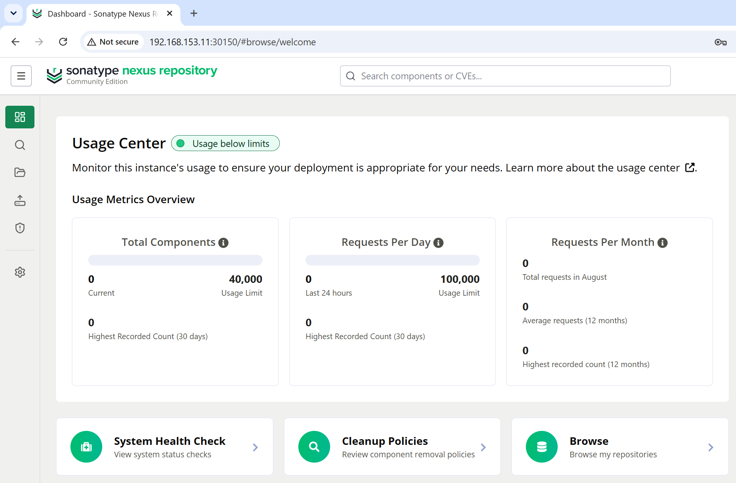

- Create test1 service
# vim test1-svc.yaml
# kubectl apply -f test1-svc.yaml
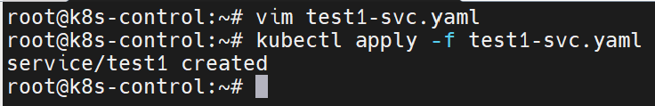

apiVersion: v1
kind: Service
metadata:
name: test1
namespace: red
spec:
type: LoadBalancer
loadBalancerIP: 192.168.153.10
selector:
app: nginx
ports:
- protocol: TCP
port: 80
targetPort: 80

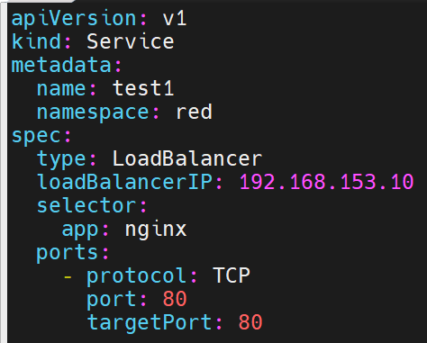

- Create MetalLB
# kubectl apply -f https://raw.githubusercontent.com/metallb/metallb/v0.16.1/config/manifests/metallb-native.yaml
# kubectl get pods -n metallb-system

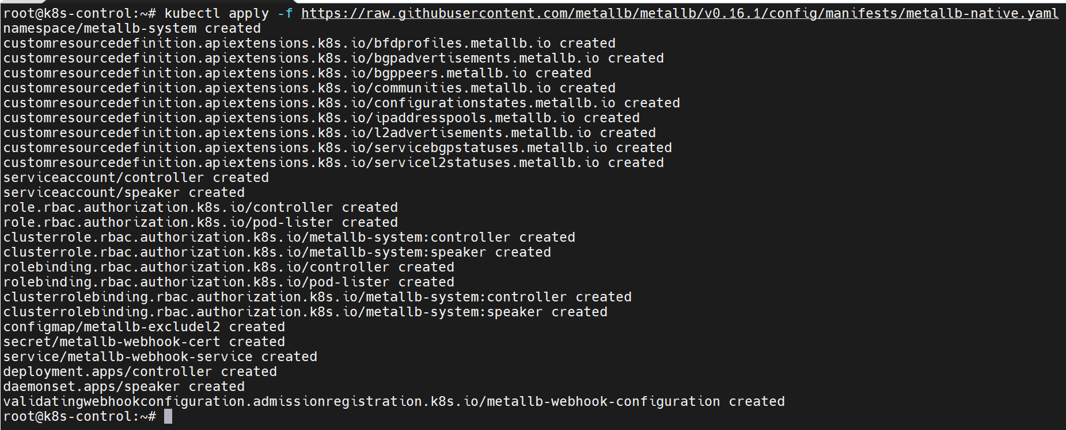
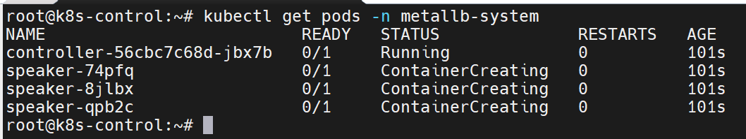
- Create ip-pool
# vim ip-pool.yaml
# kubectl apply -f ip-pool.yaml

apiVersion: metallb.io/v1beta1
kind: IPAddressPool
metadata:
name: test-pool
namespace: metallb-system
spec:
addresses:
- 192.168.153.10-192.168.153.20
autoAssign: false
---
apiVersion: metallb.io/v1beta1
kind: L2Advertisement
metadata:
name: l2-advert
namespace: metallb-system
spec:
ipAddressPools:
- test-pool
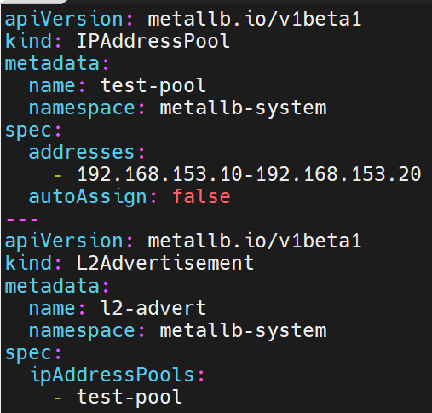

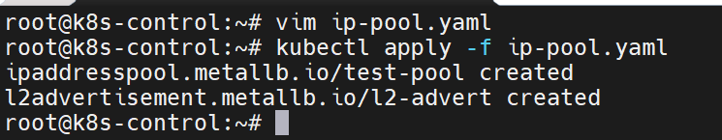

- Go to web http://192.168.153.10/

